Course Work Answer Book
UNIVERSITY COURSE WORK

REGISTRATION NUMBER |  |  |  |  |  |  |  |  | VU-BSF-2603-2363-EVE
Title of The Program (eg BBA, BSC, BPH, BSWA) |  |  |  |  |  |  |  |  |  |  |  |  | BSF
Bachelor of Science in Software Engineering
Department |  |  |  | Other Depts in Faculty of Science and Technology
Faculty | Faculty of Science and Technology
Year Of study (YrI , YrII, YrIII, or YrIV) |  |  |  |  |  |  |  |  |  |  | 1
Module Code and Name |  |  |  |  |  |  | 1203 ST
Programming Fundamentals
Semester |  |  | 2
Retake: |  | Yes |  |  | ☐ |  |  | No |  | ☐ |  | (Tick whichever is applicable)
Date of Course Work |  |  |  |  |  | Mon Aug 31 2026 00:00:00 GMT+0300 (East Africa Time)
DIRECTIONS TO CANDIDATES (Turn to page ii for more instructions). |  |  |  |  |  |  |  |  |  |  |  |  | FOR USE BY EXAMINERS ONLY
 |  |  |  |  |  |  |  |  |  |  |  |  | Question Number | Internal Examiner | External Examiner
- Leave margin blank.  - Begin each answer on a fresh page.  - Write the number of each question and theCandidate's Number at the top of each page.  - Write the numbers of the questionswhich you have attempted, with subsections where necessary, in the spacesprovided below |  |  |  |  |  |  |  |  |  |  |  |  | Question Number | Internal Examiner | External Examiner
 |  |  |  |  |  |  |  |  |  |  |  |  | TOTAL

NUMBER OF QUESTIONS you have answered in the order in which you have written them

How and where should I submit my Course Work script?
Every student will be required to submit their Course Work via VClass Students Portal E.g. you go to www.vclass.ac and login, to your account, then on the left sidebar menu click on Course Work.
Under Course Work you will see the following: -
- Instructions for that particular Course Work with time required to finish your Course Work as per instructions,
- A student will be required to download the question paper and the answer sheet provided by the university within the same module Course Work, or a student can be required to attempt structured questions within the system depending on how the Course Work was set.
- Submission of answered questions is done,
- Student is required to click to consent to show that the answered Course Work belongs to them.
- Note that if Course Work is for download, a student will be required to download the question paper and answer sheet, do their Course Work within the given stipulated time.
- Required to scan and upload back the answered booklet through the same portal as per format available.
- Course Work uploaded will directly be received by the Registry department.
- Students here are required to use VClass e-Learning systemfor all Course Work and for any failure they can contact the Registry department for guidance.No late submission will be accepted.Avoid any malpractice because this will attract severe penalties such as invalidating the answered script whose consequences will attract retakes.
Group Assignment - Option 1
Hostel Room Booking and Fees Management System
A console-based Python system replacing a paper hostel ledger
GROUP 8
1 | VU-BSF-2603-3518-EVE | KYAGULANYI SHARIF | 0751684536
2 | VU-BSF-26303-2152-EVE | LUSWATA EDWIN | 0751282196
3 | VU-BIT-2503-0436-EVE | MBABAZI BRIDGET | 0785390782
4 | VU-BIT-2503-2460-EVE | MUWANGUZI ELISHA
5 | VU-BIT-2503-2460-EVE | NALWOGA MADRINE | 0742598249
6 | VU-BSF-25603-2363-EVE | KASEMIIRE JOANITAH | 0757408372
7 | VU-BSF-25603-1101-EVE | KATEEA BERNARD | 0784702416
8 | VU-BIT-2511-0760-EVE | LUKENGE JOEL KALULE
9 | VU-BIT-2503-0024-EVE | RUBANGAKENE EMMANUEL | 0787294678
10 | VU-BIT-2503-0378-EVE | ORIADA MICHEAL | 0771801792

GitHub Repository Link
https://github.com/katsben/Hostel-Room-Booking-and-Fees-Management-System.git

1. System Design

1.1 Overview
The Hostel Room Booking and Fees Management System is a console-based Python application that digitizes a warden's paper ledger. It predefines three hostel blocks (Block A, B and C), each with a fixed set of rooms and per-room capacities. Wardens can register students into specific rooms (rejected automatically once a room is full), record full or partial fee payments over time, search for students, generate occupancy reports, and list fee defaulters above a chosen balance threshold. All data is saved to hostel_data.json and reloaded automatically the next time the programme starts.

1.2 Data Structures
Two in-memory structures drive the whole system. blocks is a dictionary mapping each block name to a dictionary of {room_number: capacity}, e.g. {"Block A": {101: 2, 102: 2, ...}}. This layout is fixed in code, since the physical building does not change at runtime. students is a dictionary keyed by registration number, where each value holds the student's name, assigned block and room, total fee due, and a list of individual payment amounts. Room occupancy is deliberately not stored as a separate counter - it is always derived on demand by counting how many students in the students dictionary are currently assigned to a given block and room. This avoids the two data structures ever going out of sync with each other (e.g. a room's occupant count disagreeing with who is actually recorded as staying there).

1.3 Key Design Decisions
- Derived occupancy instead of a stored counter: eliminates an entire class of bugs where room counts and student records could drift apart after edits.
- Balance is always computed, never stored: get_balance() = total_fee - sum(payments), recalculated every time it's needed, so multiple partial payments are always reflected correctly without a separate 'update balance' step that could be forgotten.
- JSON for persistence: the Python standard library's json module handles the nested blocks/students structure directly, with no external dependencies and no fragile custom text parsing.
- Small, reusable input-validation helpers (get_positive_number, get_non_negative_number, get_valid_block, get_valid_room) are shared across every section that needs them, rather than each function reinventing its own validation.
The table below maps each assignment requirement to the function(s) that satisfy it.
Requirement | How it's satisfied
a) Data setup | get_initial_blocks() hard-codes 3 blocks (A, B, C) as a dict of {room: capacity}. print_occupancy_overview() summarises capacity/occupied/vacant per block at startup.
b) Registration & allocation | register_student() checks the room's current occupancy (derived live from student records) against its capacity before allocating; rejects with a clear message if full.
c) Fee payment recording | record_payment() appends each payment to a per-student list; get_balance() always recomputes total_fee minus the sum of payments, so partial payments over time are handled correctly.
d) Search & reporting | search_student() matches by exact reg. no. or case-insensitive name substring. generate_block_report() tabulates every room per block. list_fee_defaulters() filters students above a chosen balance threshold.
e) File persistence | save_data()/load_data() use JSON. A missing file returns a fresh default state; a corrupted file is caught by a broad except clause and also falls back gracefully, with a warning printed either way.
f) Menu-driven driver | main() loops on display_menu() until 'Save and exit'; every choice and every field entered is validated by small reusable helper functions so invalid input never crashes the programme.

2. How the Group Divided the Work
The system was split along the same four functional sections defined in the assignment brief, so each member owned one section end-to-end (design, implementation and testing of their own functions), with the menu-driven driver programme integrated and tested together as a group.
Member | Primary Responsibility | Functions Authored
Member 1 - [Name] | Data setup & file persistence (Sections A, E) | get_initial_blocks(), print_occupancy_overview(), save_data(), load_data()
Member 2 - [Name] | Registration & room allocation (Section B) | register_student(), get_valid_block(), get_valid_room()
Member 3 - [Name] | Fee payment recording (Section C) | record_payment(), get_total_paid(), get_balance()
Member 4 - [Name] | Search & reporting (Section D) | search_student(), generate_block_report(), list_fee_defaulters()
All members | Menu integration, input validation helpers, and testing (Section F) | main(), display_menu(), handle_occupancy_report_menu(), handle_defaulters_menu(), shared validation helpers

Each member is individually able to explain and demonstrate the section above, and has reviewed the rest of the codebase sufficiently to answer viva questions on any part of the system, per the assignment's requirement that presentation marks are awarded per individual.

3. Challenges We Overcame
- Keeping room occupancy and student records consistent: our first draft stored a separate 'current occupants' counter on each room, which could drift out of sync if a student record was edited directly. We resolved this by deriving occupancy live from the students dictionary instead, removing the possibility of the two disagreeing.
- Handling partial and overlapping payments: deciding how to treat a payment that exceeds the remaining balance took some discussion. We settled on capping the displayed balance at zero while still recording the full payment amount and explicitly informing the user of the overpayment, rather than silently rejecting it or letting the balance go negative.
- Corrupted data file recovery: initially a malformed hostel_data.json (e.g. from a crash mid-write, or manual editing) caused a JSONDecodeError that crashed the whole programme on startup. We fixed this by wrapping the load in a try/except that catches decoding, key, type and OS-level errors, prints a clear warning, and falls back to a fresh dataset instead of crashing.
- Threshold edge case in the defaulters report: we initially validated the defaulter threshold with the same 'must be positive' check used for payments, which incorrectly rejected a threshold of 0 (a legitimate query meaning 'show anyone who owes anything at all'). We added a separate get_non_negative_number() helper specifically for this case.
- Agreeing on a shared coding style across four contributors: to keep the codebase consistent, the group agreed in advance on naming conventions (snake_case functions, descriptive variable names), a shared docstring format, and section-header comments marking which requirement (a-f) each block of code satisfies.

4. Step-by-Step Screenshots
The following screenshots were captured from real runs of hostel_system.py (terminal output re-rendered as images for clarity), demonstrating every menu option and edge case working correctly.

Step 1 - Startup Overview, Invalid Menu Choice, Room Allocation

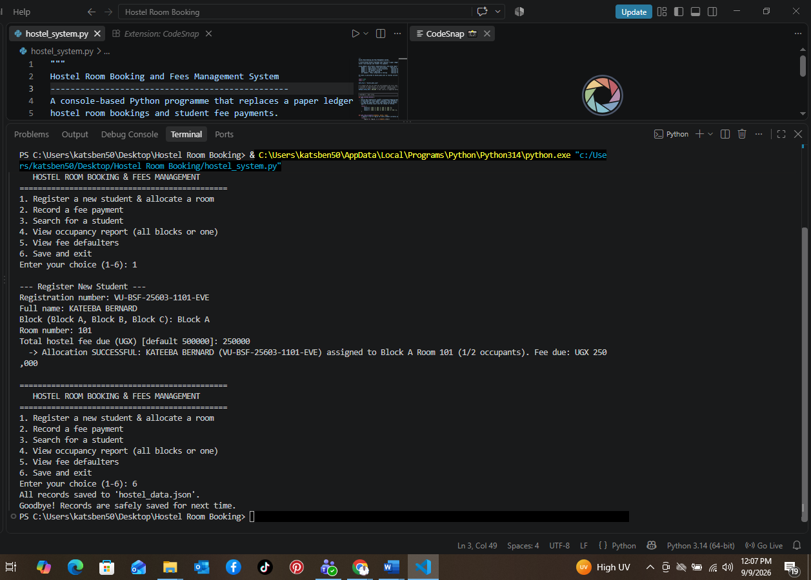
The predefined block layout is summarised on startup. An invalid menu choice ('9') is rejected without crashing. Two students are then registered into the same room, filling it to capacity (2/2). Demonstrates requirements (a), (b) and (f).

Step 2 - Allocation Rejected When Room Is Full

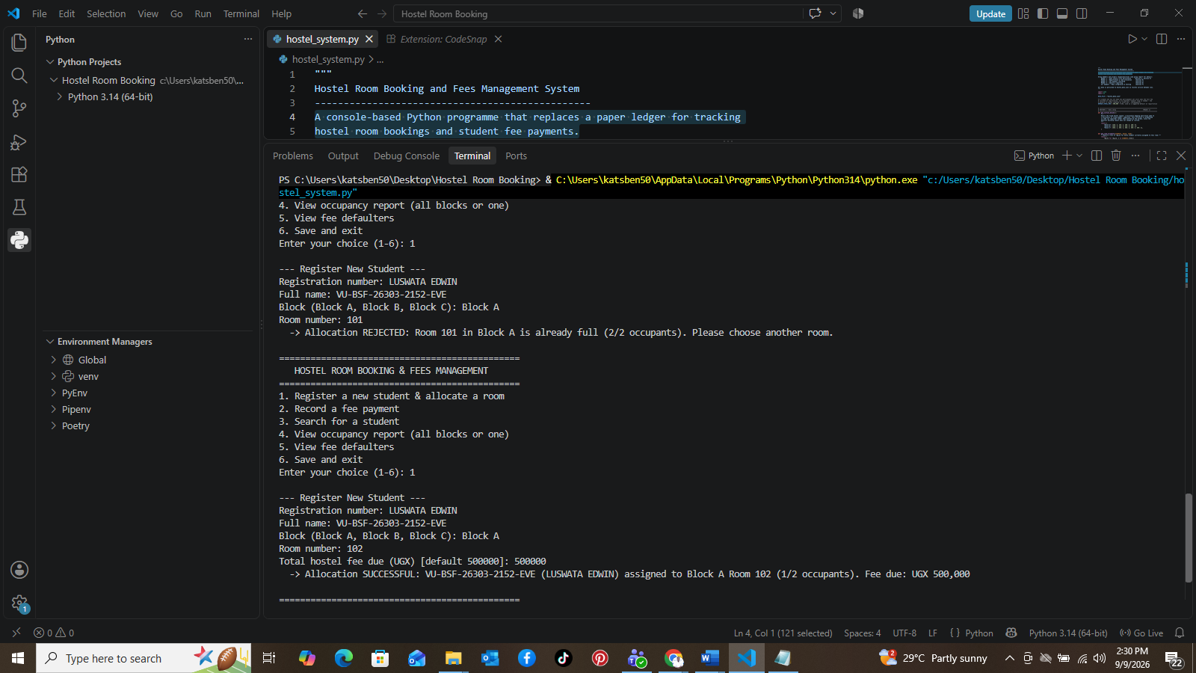
A third student is rejected from the now-full room with a clear explanation, then successfully allocated to a different block/room with a custom fee amount. Demonstrates requirement (b).

Step 3 - Fee Payments: Partial, Validation, Overpayment, Fully Paid
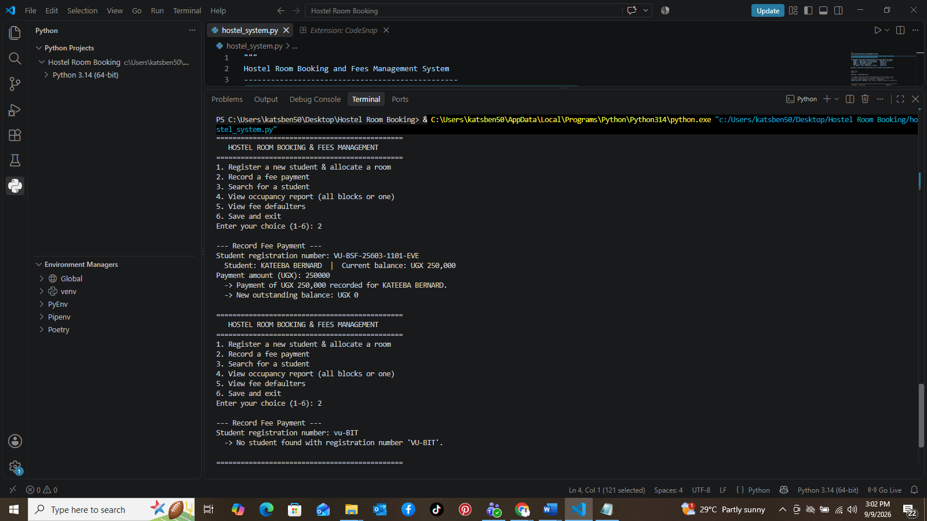
A partial payment reduces the balance correctly. A payment against an unknown registration number is rejected. Invalid amounts (negative, non-numeric) are re-prompted. A payment exceeding the remaining balance is accepted with an overpayment note, and a further payment against a fully-paid student is blocked. Demonstrates requirement (c).

Step 4 - Search by Registration Number and by Name
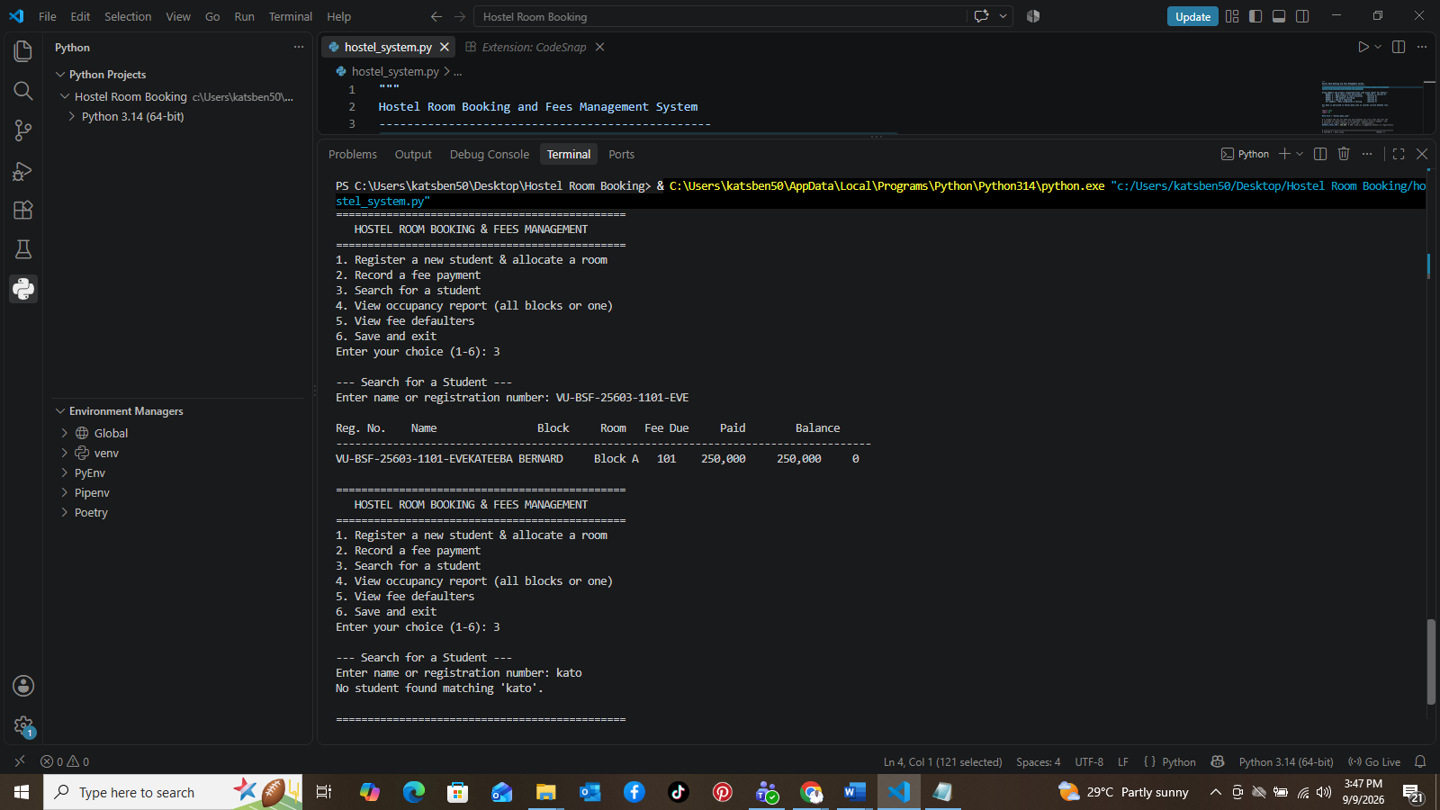
Searching by exact registration number returns the student's full record. Searching by a name with no match ('kato', 'zzz') shows a clear message instead of an empty table. Demonstrates requirement (d).

Step 5 - Occupancy Report: All Blocks and a Single Block
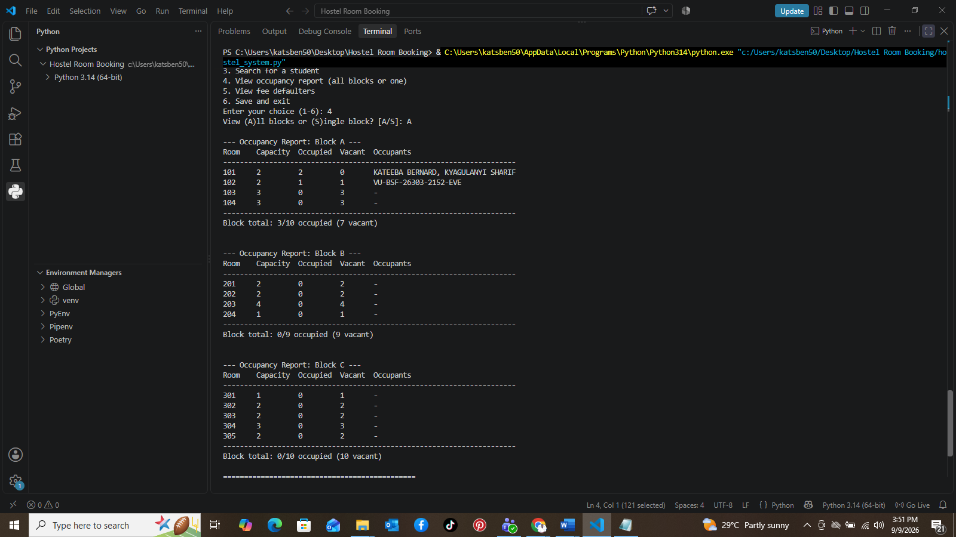1
The full occupancy report lists every room across all three blocks with capacity, occupied, vacant counts and named occupants, plus a per-block subtotal. The same report can be filtered to a single block. Demonstrates requirement (d).

Step 6 - Fee Defaulters Report, Save and Exit
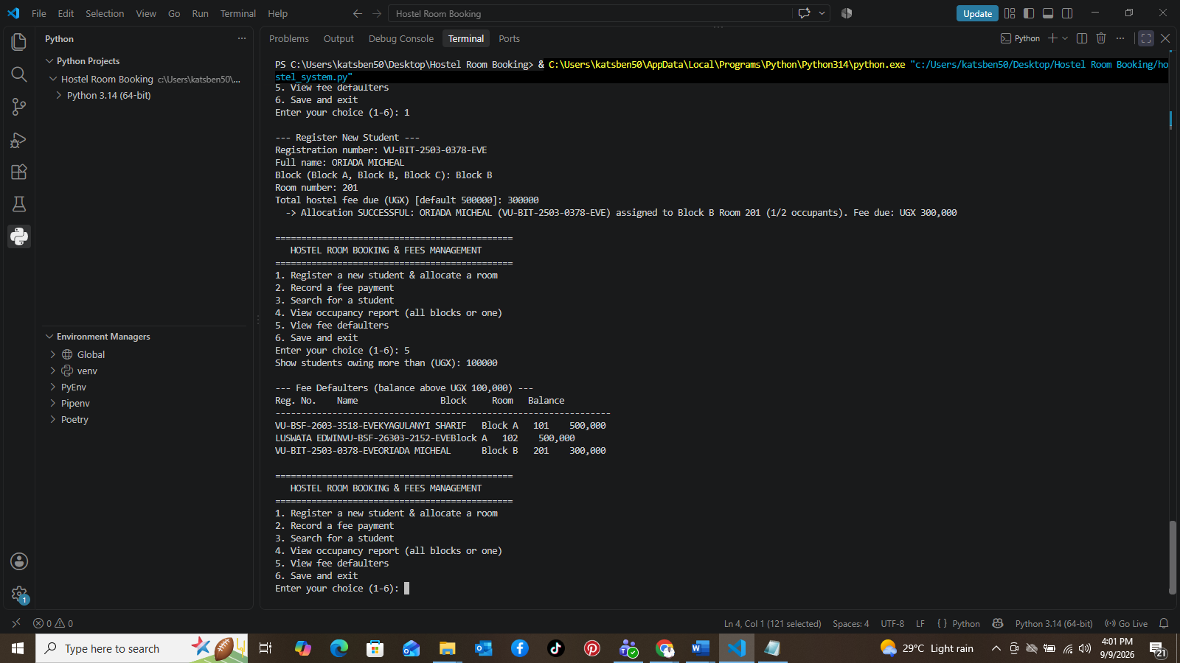
Students whose balance exceeds a chosen threshold (UGX 100,000) are listed, sorted highest balance first. Choosing 'Save and exit' writes all records to hostel_data.json. Demonstrates requirements (d), (e) and (f).

Step 7 - Second Run: Data Reloaded, New Student Registered

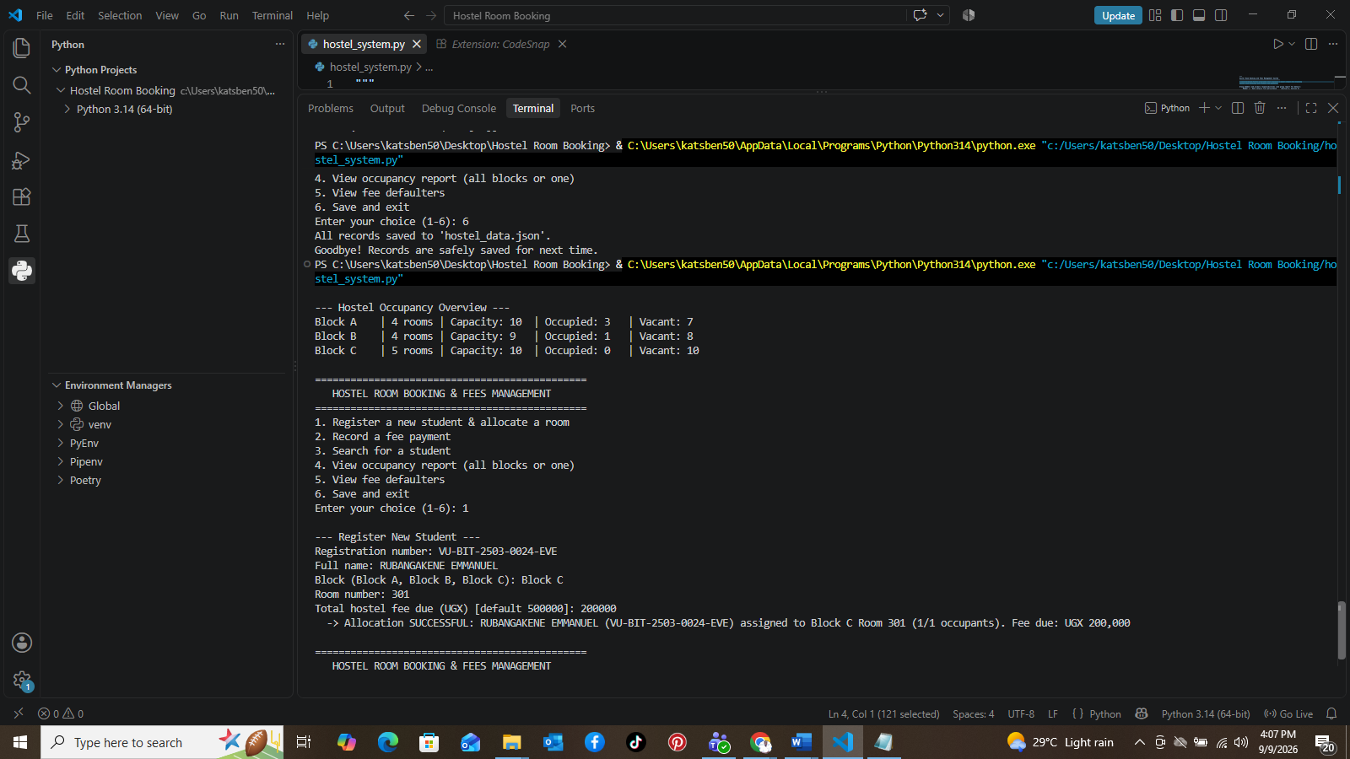
Restarting the programme automatically reloads all previously saved students and rooms into the startup overview. A new student is then registered into Block C.
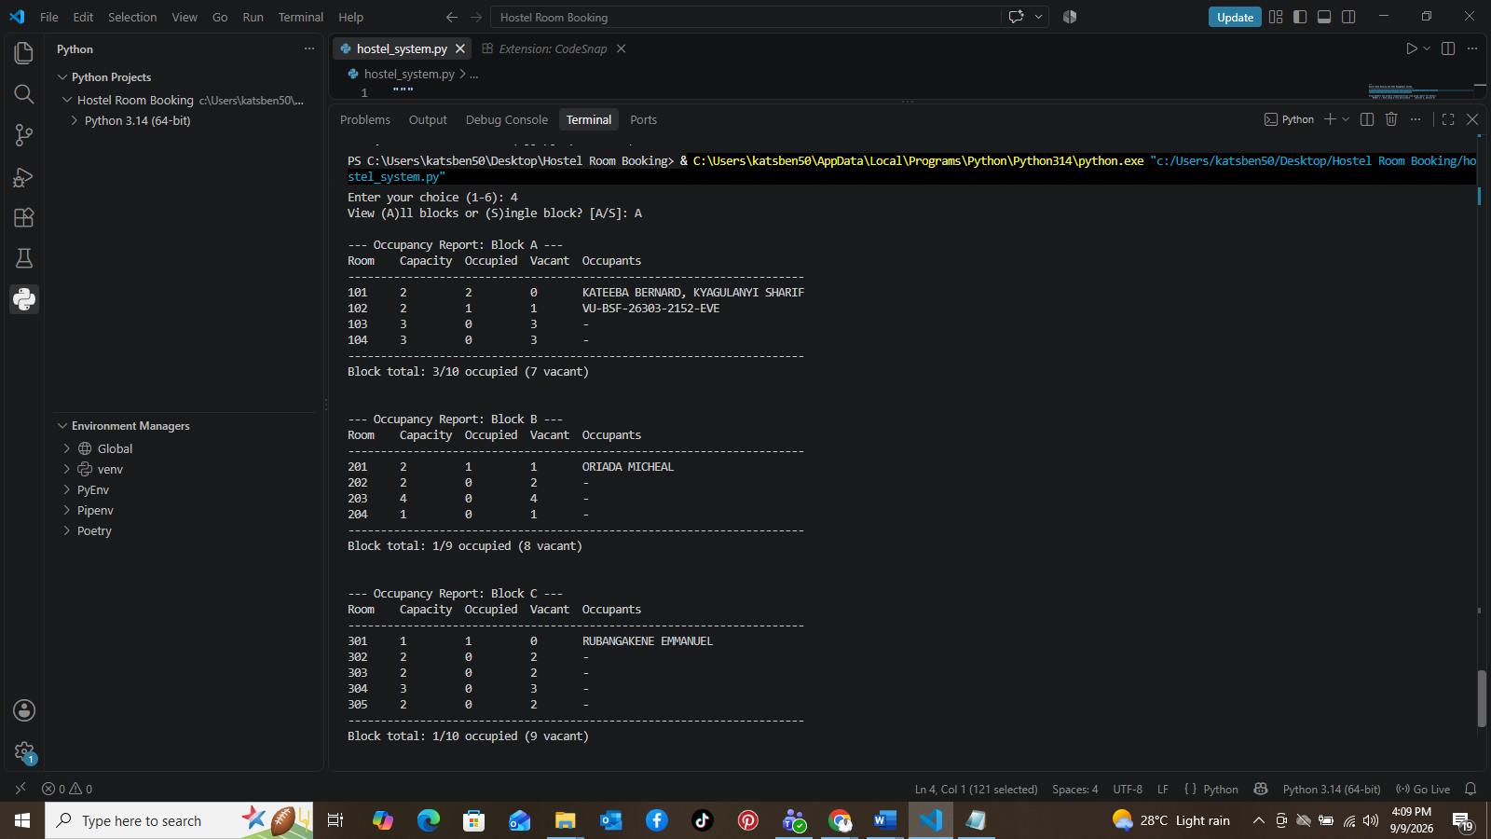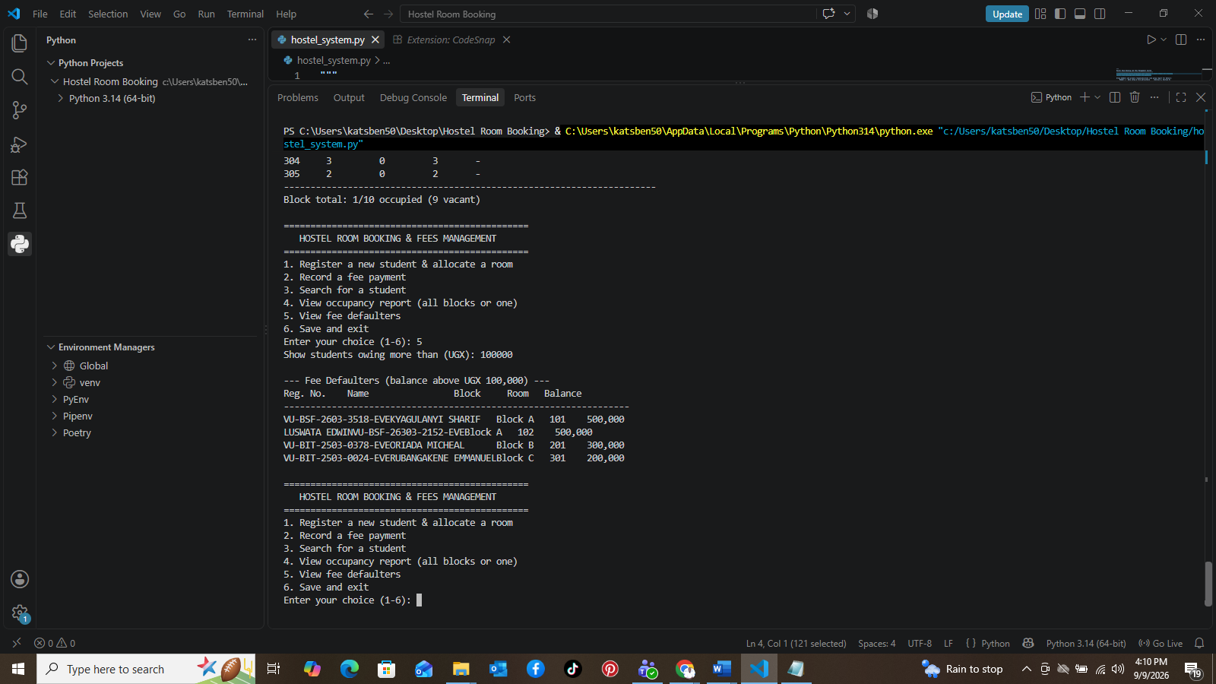
The occupancy report and fee-defaulters list correctly include the newly registered student alongside everyone reloaded from disk, proving persistence works across multiple runs. Demonstrates requirement (e).

Step 8 - Corrupted File Recovery, Input Validation, Duplicate Rejected
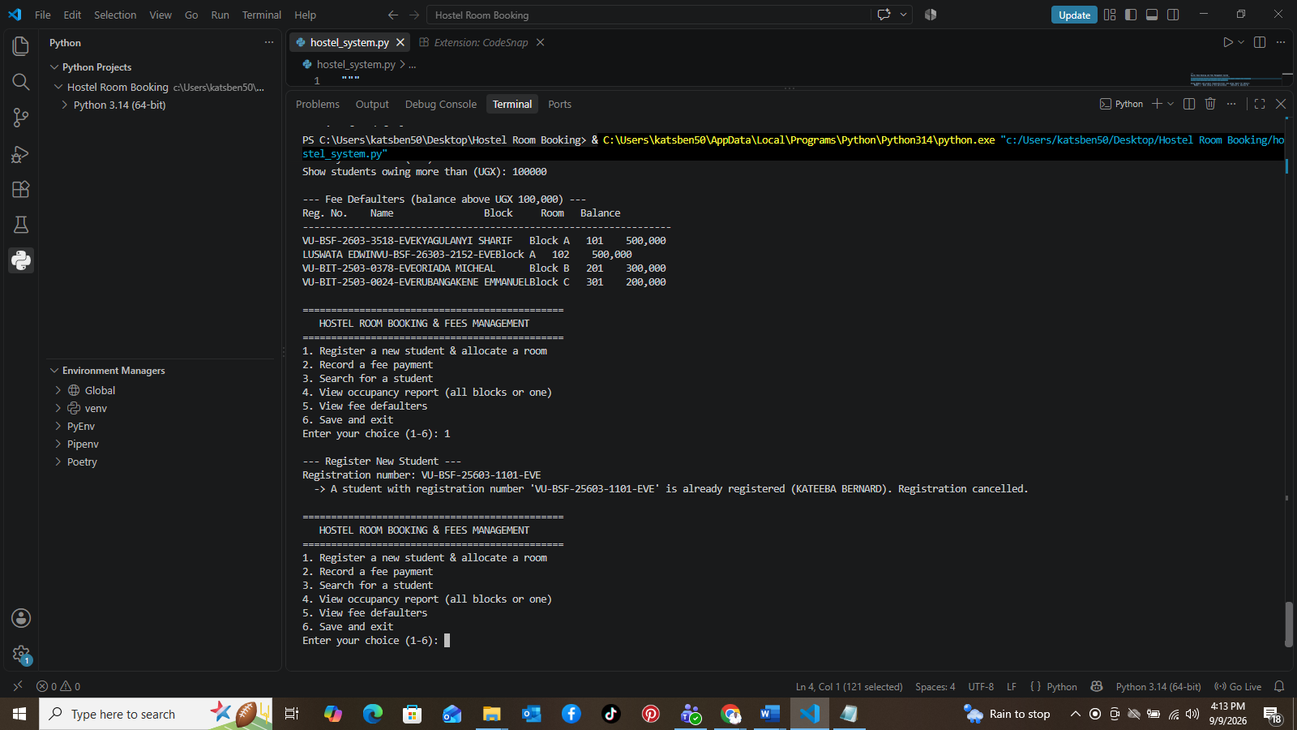
With hostel_data.json deliberately corrupted, the programme detects this, warns the user, and starts fresh rather than crashing. Registration then demonstrates the block-name and room-number validation loops, and a duplicate registration number is correctly rejected. Demonstrates requirements (b), (e) and (f).

Appendix A - Full Source Code (hostel_system.py)
Included below for completeness; the authoritative, version-controlled copy is in the GitHub repository linked at the top of this document.
"""
Hostel Room Booking and Fees Management System
------------------------------------------------
A console-based Python programme that replaces a paper ledger for tracking
hostel room bookings and student fee payments.

Group members and primary responsibilities (see group report for detail):
Member 1 - Data setup & file persistence (Section A, Section E)
Member 2 - Registration & room allocation (Section B)
Member 3 - Fee payment recording (Section C)
Member 4 - Search & reporting (Section D)
All members - Menu integration & testing (Section F)

All data is persisted to hostel_data.json so records survive between runs.
"""

import json
import os

DATA_FILE = "hostel_data.json"

# A student who has not made any part-payment yet still owes the full fee
# recorded at registration, so no separate "unpaid" flag is needed - the
# balance is always computed as total_fee - sum(payments).
DEFAULT_TOTAL_FEE = 500_000 # UGX, used as a suggested default at registration

# =============================================================================
# SECTION A - Data setup (Member 1)
# =============================================================================
def get_initial_blocks():
"""
Return the fixed hostel layout: a dictionary mapping each block name to
a dictionary of {room_number: capacity}. This structure is predefined
in code (as required) rather than entered by the warden, since the
physical building layout does not change at runtime.
"""
return {
"Block A": {101: 2, 102: 2, 103: 3, 104: 3},
"Block B": {201: 2, 202: 2, 203: 4, 204: 1},
"Block C": {301: 1, 302: 2, 303: 2, 304: 3, 305: 2},
}

def get_room_occupants(students, block, room):
"""Return a list of reg_no for every student currently assigned to this room."""
return [
reg_no for reg_no, s in students.items()
if s["block"] == block and s["room"] == room
]

def get_room_occupancy_count(students, block, room):
"""Return how many students currently occupy the given room."""
return len(get_room_occupants(students, block, room))

def print_occupancy_overview(blocks, students):
"""Print a brief one-line-per-block occupancy summary when the programme starts."""
print("\n--- Hostel Occupancy Overview ---")
for block, rooms in blocks.items():
total_capacity = sum(rooms.values())
total_occupied = sum(
get_room_occupancy_count(students, block, room) for room in rooms
)
vacancies = total_capacity - total_occupied
print(f"{block:<10} | {len(rooms)} rooms | "
f"Capacity: {total_capacity:<3} | Occupied: {total_occupied:<3} | "
f"Vacant: {vacancies}")
print()

# =============================================================================
# Shared input-validation helpers
# =============================================================================
def get_non_empty_string(prompt):
"""Repeatedly prompt until the user enters some non-blank text."""
while True:
value = input(prompt).strip()
if value:
return value
print(" -> This field cannot be empty. Please try again.")

def get_positive_number(prompt):
"""Repeatedly prompt until a valid positive number is entered."""
while True:
raw_value = input(prompt).strip()
try:
value = float(raw_value)
except ValueError:
print(" -> That doesn't look like a number. Please try again.")
continue
if value <= 0:
print(" -> Value must be greater than zero. Please try again.")
continue
return value

def get_non_negative_number(prompt):
"""Repeatedly prompt until a valid number >= 0 is entered (0 itself is allowed)."""
while True:
raw_value = input(prompt).strip()
try:
value = float(raw_value)
except ValueError:
print(" -> That doesn't look like a number. Please try again.")
continue
if value < 0:
print(" -> Value cannot be negative. Please try again.")
continue
return value

def get_valid_block(prompt, blocks):
"""Repeatedly prompt until the user names an existing hostel block."""
while True:
block = input(prompt).strip()
# Case-insensitive match against the predefined block names.
for existing in blocks:
if existing.lower() == block.lower():
return existing
print(f" -> No such block. Available blocks: {', '.join(blocks.keys())}")

def get_valid_room(prompt, blocks, block):
"""Repeatedly prompt until the user names an existing room number in `block`."""
while True:
raw_room = input(prompt).strip()
try:
room = int(raw_room)
except ValueError:
print(" -> Room number must be a whole number. Please try again.")
continue
if room not in blocks[block]:
print(f" -> Room {room} does not exist in {block}. "
f"Valid rooms: {sorted(blocks[block].keys())}")
continue
return room

# =============================================================================
# SECTION B - Student registration and room allocation (Member 2)
# =============================================================================
def register_student(students, blocks):
"""
Register a new student and allocate them to a specified room, but only
if space remains in it. Rejects the allocation with a clear explanation
if the room is already full, and updates occupancy automatically since
occupancy is always derived from the `students` dictionary.
"""
print("\n--- Register New Student ---")
reg_no = get_non_empty_string("Registration number: ").upper()

if reg_no in students:
print(f" -> A student with registration number '{reg_no}' is already "
f"registered ({students[reg_no]['name']}). Registration cancelled.\n")
return

name = get_non_empty_string("Full name: ")
block = get_valid_block(f"Block ({', '.join(blocks.keys())}): ", blocks)
room = get_valid_room("Room number: ", blocks, block)

capacity = blocks[block][room]
current_occupancy = get_room_occupancy_count(students, block, room)

if current_occupancy >= capacity:
print(f" -> Allocation REJECTED: Room {room} in {block} is already full "
f"({current_occupancy}/{capacity} occupants). Please choose another "
f"room.\n")
return

fee_prompt = f"Total hostel fee due (UGX) [default {DEFAULT_TOTAL_FEE}]: "
raw_fee = input(fee_prompt).strip()
if raw_fee == "":
total_fee = DEFAULT_TOTAL_FEE
else:
try:
total_fee = float(raw_fee)
if total_fee <= 0:
print(" -> Fee must be positive; using default instead.")
total_fee = DEFAULT_TOTAL_FEE
except ValueError:
print(" -> Invalid amount; using default instead.")
total_fee = DEFAULT_TOTAL_FEE

students[reg_no] = {
"name": name,
"block": block,
"room": room,
"total_fee": total_fee,
"payments": [], # list of individual payment amounts
}

new_occupancy = current_occupancy + 1
print(f" -> Allocation SUCCESSFUL: {name} ({reg_no}) assigned to {block} "
f"Room {room} ({new_occupancy}/{capacity} occupants). "
f"Fee due: UGX {total_fee:,.0f}\n")

# =============================================================================
# SECTION C - Fee payment recording (Member 3)
# =============================================================================
def get_total_paid(student):
"""Sum every payment made so far by this student."""
return sum(student["payments"])

def get_balance(student):
"""Outstanding balance = total fee due minus everything paid so far (never negative)."""
return max(0.0, student["total_fee"] - get_total_paid(student))

def record_payment(students):
"""
Record a full or partial fee payment against a student's account and
correctly update their outstanding balance. Supports multiple payments
made over time for the same student.
"""
print("\n--- Record Fee Payment ---")
reg_no = get_non_empty_string("Student registration number: ").upper()

if reg_no not in students:
print(f" -> No student found with registration number '{reg_no}'.\n")
return

student = students[reg_no]
balance_before = get_balance(student)
print(f" Student: {student['name']} | Current balance: UGX {balance_before:,.0f}")

if balance_before == 0:
print(" -> This student has already fully paid their fees. "
"No further payment is required.\n")
return

amount = get_positive_number("Payment amount (UGX): ")

student["payments"].append(amount)
balance_after = get_balance(student)

print(f" -> Payment of UGX {amount:,.0f} recorded for {student['name']}.")
if amount > balance_before:
overpaid = amount - balance_before
print(f" -> Note: this payment exceeds the outstanding balance by "
f"UGX {overpaid:,.0f} (balance is now UGX 0).")
print(f" -> New outstanding balance: UGX {balance_after:,.0f}\n")

# =============================================================================
# SECTION D - Search and reporting (Member 4)
# =============================================================================
def search_student(students):
"""
Search for a student by exact registration number or by a case-insensitive
substring match on their name, and display their full record.
"""
print("\n--- Search for a Student ---")
query = get_non_empty_string("Enter name or registration number: ").strip()
query_lower = query.lower()

matches = []
for reg_no, s in students.items():
if reg_no.lower() == query_lower or query_lower in s["name"].lower():
matches.append((reg_no, s))

if not matches:
print(f"No student found matching '{query}'.\n")
return

print(f"\n{'Reg. No.':<12}{'Name':<20}{'Block':<10}{'Room':<7}"
f"{'Fee Due':<12}{'Paid':<12}{'Balance':<12}")
print("-" * 85)
for reg_no, s in matches:
paid = get_total_paid(s)
balance = get_balance(s)
print(f"{reg_no:<12}{s['name']:<20}{s['block']:<10}{s['room']:<7}"
f"{s['total_fee']:<12,.0f}{paid:<12,.0f}{balance:<12,.0f}")
print()

def generate_block_report(blocks, students, block_name=None):
"""
Print a full occupancy report. If `block_name` is None, report on every
block; otherwise report on just that one block.
"""
blocks_to_report = [block_name] if block_name else list(blocks.keys())

for block in blocks_to_report:
print(f"\n--- Occupancy Report: {block} ---")
print(f"{'Room':<8}{'Capacity':<10}{'Occupied':<10}{'Vacant':<8}Occupants")
print("-" * 70)

block_capacity = 0
block_occupied = 0
for room, capacity in sorted(blocks[block].items()):
occupants = get_room_occupants(students, block, room)
occupied = len(occupants)
vacant = capacity - occupied
names = ", ".join(students[r]["name"] for r in occupants) or "-"
print(f"{room:<8}{capacity:<10}{occupied:<10}{vacant:<8}{names}")
block_capacity += capacity
block_occupied += occupied

print("-" * 70)
print(f"Block total: {block_occupied}/{block_capacity} occupied "
f"({block_capacity - block_occupied} vacant)\n")

def list_fee_defaulters(students, threshold):
"""
Print every student whose outstanding balance is strictly above
`threshold`, sorted from the highest balance to the lowest. Shows a
clear message if there are no defaulters rather than an empty table.
"""
defaulters = [
(reg_no, s, get_balance(s))
for reg_no, s in students.items()
if get_balance(s) > threshold
]

print(f"\n--- Fee Defaulters (balance above UGX {threshold:,.0f}) ---")
if not defaulters:
print("No fee defaulters found above this threshold. Good news!\n")
return

defaulters.sort(key=lambda item: item[2], reverse=True)

print(f"{'Reg. No.':<12}{'Name':<20}{'Block':<10}{'Room':<7}{'Balance':<12}")
print("-" * 65)
for reg_no, s, balance in defaulters:
print(f"{reg_no:<12}{s['name']:<20}{s['block']:<10}{s['room']:<7}{balance:<12,.0f}")
print()

# =============================================================================
# SECTION E - File persistence (Member 1)
# =============================================================================
def save_data(blocks, students):
"""Save the current blocks layout and every student record to DATA_FILE."""
payload = {"blocks": blocks, "students": students}
with open(DATA_FILE, "w", encoding="utf-8") as f:
# `default=str` is a safety net in case any non-JSON-native type
# sneaks in; keys must be strings for JSON, so room numbers below
# are converted back to int on load.
json.dump(payload, f, indent=2)
print(f"All records saved to '{DATA_FILE}'.")

def load_data():
"""
Load blocks and students from DATA_FILE if it exists and is valid.
Falls back to the predefined block layout and an empty student list if
the file is missing (first run) or damaged/corrupted, so the programme
never crashes on startup.
"""
default_blocks = get_initial_blocks()

if not os.path.exists(DATA_FILE):
# Expected on the very first run - nothing to load yet.
print(f"No existing data file found ('{DATA_FILE}'). "
f"Starting fresh with the predefined hostel layout.\n")
return default_blocks, {}

try:
with open(DATA_FILE, "r", encoding="utf-8") as f:
payload = json.load(f)

# JSON object keys are always strings, so room numbers need
# converting back from "101" to 101 for each block.
raw_blocks = payload.get("blocks", default_blocks)
blocks = {
block: {int(room): capacity for room, capacity in rooms.items()}
for block, rooms in raw_blocks.items()
}

students = payload.get("students", {})
# Room numbers inside each student record must also be int, and
# payments must be a list, to behave correctly with the rest of
# the programme's logic.
for s in students.values():
s["room"] = int(s["room"])
s["payments"] = list(s.get("payments", []))

return blocks, students

except (json.JSONDecodeError, KeyError, ValueError, TypeError, OSError) as error:
# The file exists but is unreadable/corrupted - warn the warden and
# start fresh rather than crashing the whole programme.
print(f"Warning: '{DATA_FILE}' could not be read ({error}). "
f"Starting with a fresh, empty dataset instead.\n")
return default_blocks, {}

# =============================================================================
# SECTION F - Menu-driven driver programme (All members)
# =============================================================================
def display_menu():
"""Print the main menu in plain language a non-programmer warden can follow."""
print("=" * 46)
print(" HOSTEL ROOM BOOKING & FEES MANAGEMENT")
print("=" * 46)
print("1. Register a new student & allocate a room")
print("2. Record a fee payment")
print("3. Search for a student")
print("4. View occupancy report (all blocks or one)")
print("5. View fee defaulters")
print("6. Save and exit")

def handle_occupancy_report_menu(blocks, students):
"""Sub-menu: let the warden view all blocks at once or pick a single block."""
choice = input("View (A)ll blocks or (S)ingle block? [A/S]: ").strip().lower()
if choice == "s":
block = get_valid_block(f"Which block? ({', '.join(blocks.keys())}): ", blocks)
generate_block_report(blocks, students, block)
else:
generate_block_report(blocks, students)

def handle_defaulters_menu(students):
"""Sub-menu: ask for the balance threshold before listing defaulters."""
threshold = get_non_negative_number("Show students owing more than (UGX): ")
list_fee_defaulters(students, threshold)

def main():
"""
Programme entry point. Loads existing data, prints the startup occupancy
overview, then loops through the menu until the warden chooses to save
and exit. Every menu choice is validated so the programme never crashes
on unexpected input.
"""
blocks, students = load_data()
print_occupancy_overview(blocks, students)

while True:
display_menu()
choice = input("Enter your choice (1-6): ").strip()

if choice == "1":
register_student(students, blocks)
elif choice == "2":
record_payment(students)
elif choice == "3":
search_student(students)
elif choice == "4":
handle_occupancy_report_menu(blocks, students)
elif choice == "5":
handle_defaulters_menu(students)
elif choice == "6":
save_data(blocks, students)
print("Goodbye! Records are safely saved for next time.")
break
else:
print("Invalid choice. Please enter a number from 1 to 6.\n")

if __name__ == "__main__":
main()

